VLSI Homework3

學號：B073040050

姓名：翁昌閔

## full_adder(problem1)

**A.【list the results of propagation delay and compare the worse_case delay of Pre-simulstion and Post-simulation in Hspice simulation】**

**面積：902.56 ‬ um*um**

**需如下圖使用(problem 1. 2. 3. 此處皆使用level 0)，並顯示用量尺量測**

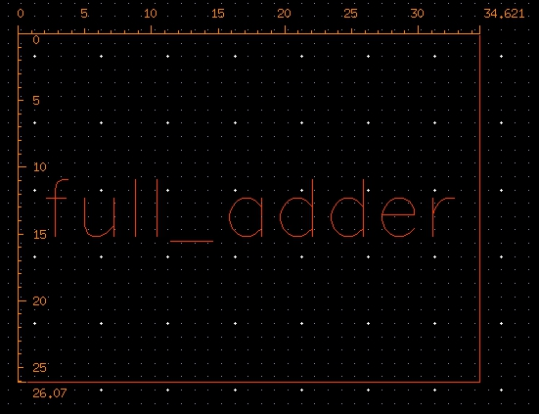

* **Hspice**

|  |  |  |  |  |  |  |  |  |  |  |  |
| --- | --- | --- | --- | --- | --- | --- | --- | --- | --- | --- | --- |
| Cload = 0.01 pF、Temp = 25°C、PC = TT | | | |  |  |  |  |  |  |  |  |
|  | | Cout | | | Sum | | | SP(Watts) | DP(Watts) | | |
| TpHL | TpLH | Tpd | TpHL | TpLH | Tpd | max | min | avg |
| pre_sim | measure_A | 10.0389n | -9.7639n | 10.0389n | 293.1697p | 291.6987p | 293.1697p | 306.6077p | 855.6240u | 207.0064p | 7.5113u |
| measure_B | 10.0408n | -9.7684n | 10.0408n | 285.3505p | 288.8510p | 285.3505p | 305.3729p | 795.5879u | 207.0064p | 7.2992u |
| measure_Cin | 10.0392n | -9.7680n | 10.0392n | 184.1638p | 185.6607p | 185.6607p | 306.6077p | 833.2032u | 229.6574p | 5.1946u |
| post_sim | measure_A |  |  |  |  |  |  |  |  |  |  |
| measure_B |  |  |  |  |  |  |  |  |  |  |
| measure_Cin |  |  |  |  |  |  |  |  |  |  |

**B.【schematic view】**

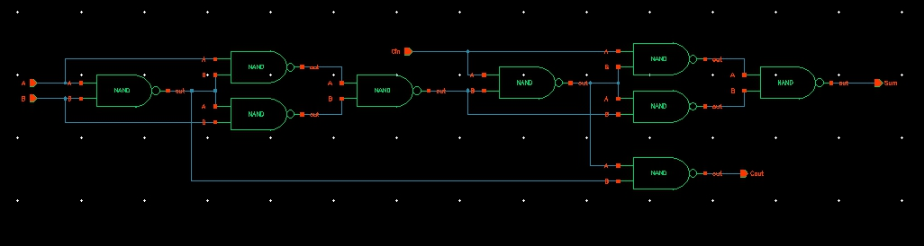

**C.【Layout view】 (problem 1. 2. 3. 此處皆使用Level10)**

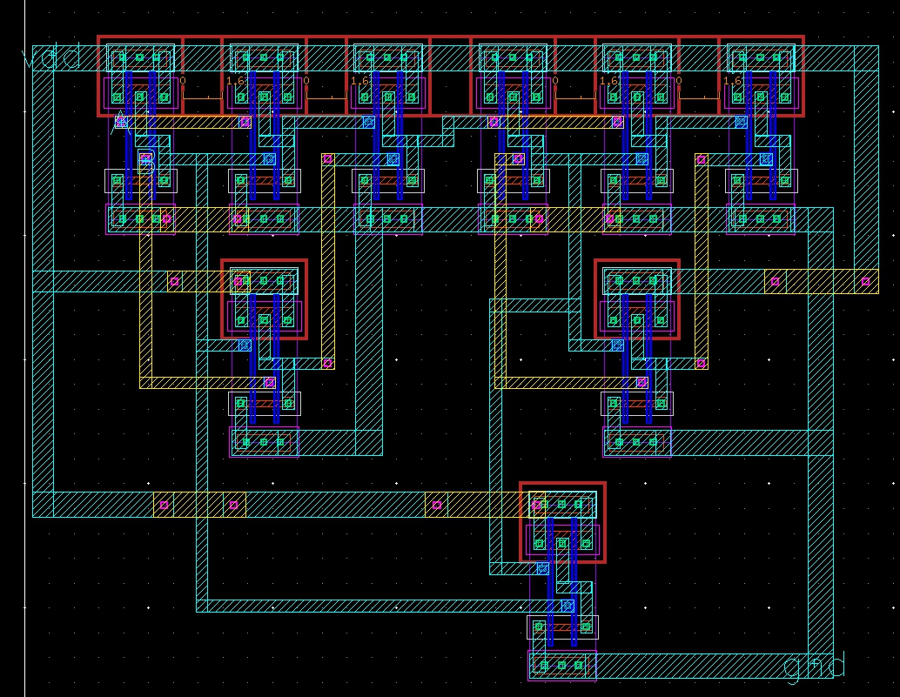

**D.【DRC successful view】**

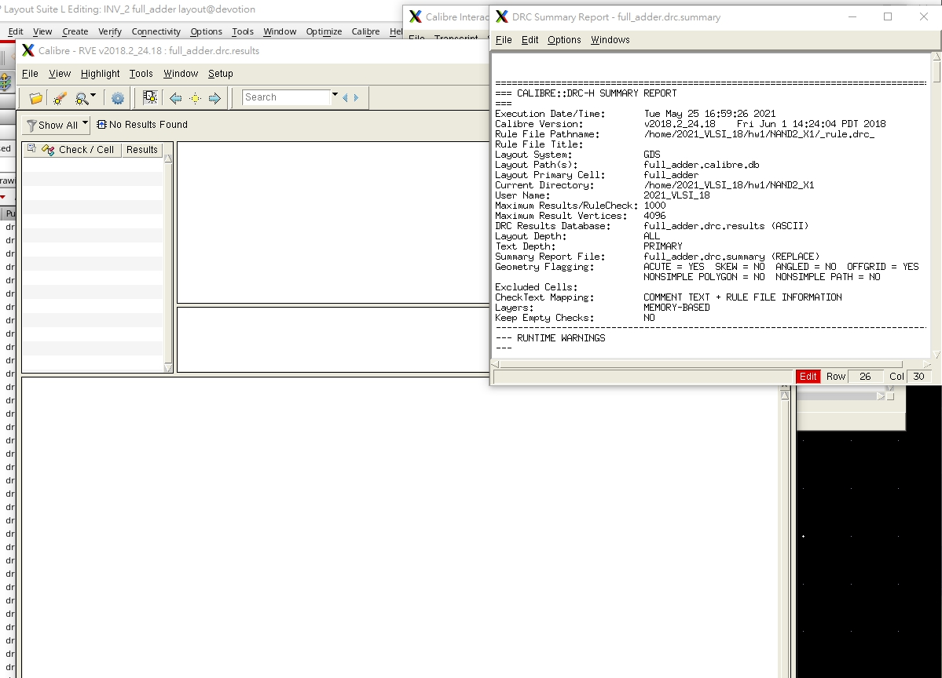

**E.【LVS successful view】**

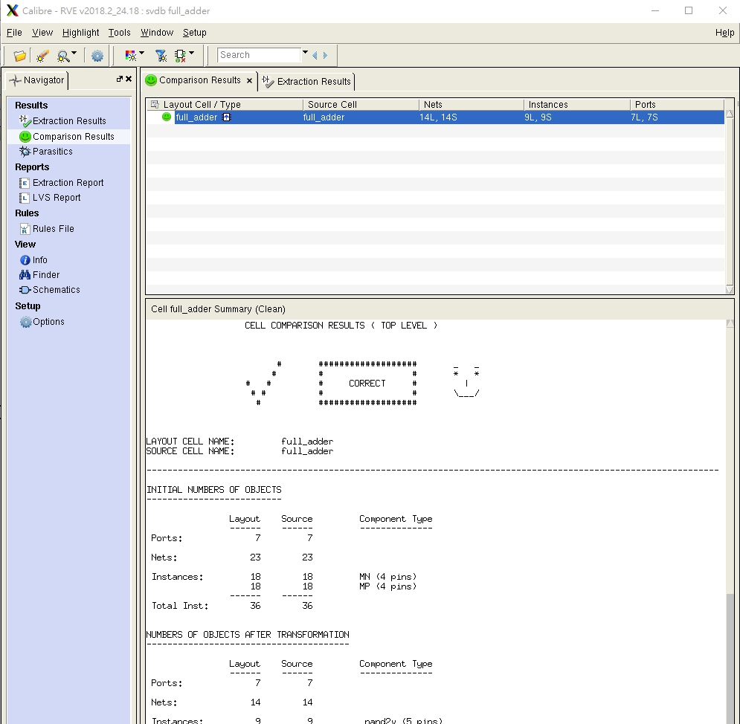

**F.【Pre-layout and Post-layout simulation waveforms】**

**(要包含所有真值表上的值)**

**F-1.(Pre-layout)**

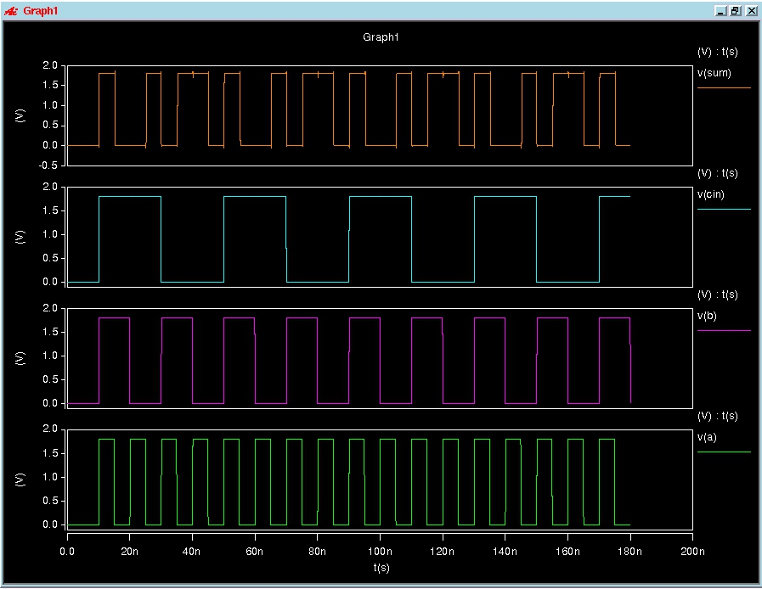

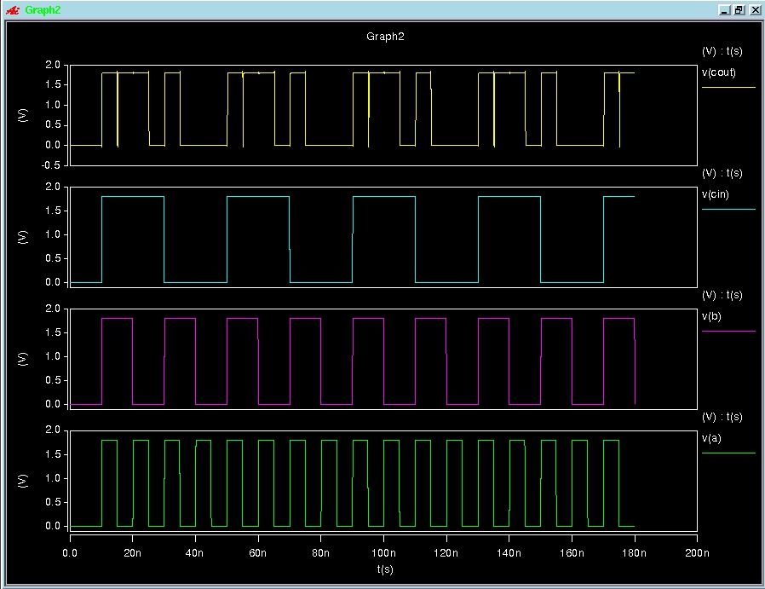

**F-2.(Post-layout)**

## full_adder(problem2)

**A.【list the results of propagation delay and compare the worse_case delay of Pre-simulstion and Post-simulation in Hspice simulation】**

**面積：?? um*um**

**CMOS_F1：**

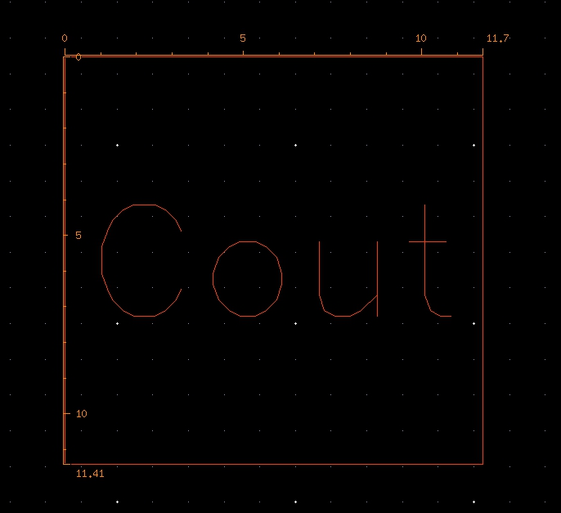

**CMOS_F2：**

**FA：**

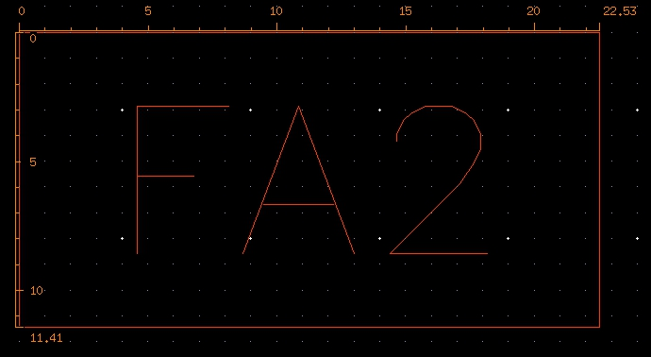

* **Hspice**

|  |  |  |  |  |
| --- | --- | --- | --- | --- |
| Cload = 0.01 pF、Temp = 25°C、PC = TT (CMOS_F1) | | | |  |
|  | | ~Cout | | |
| TpHL | TpLH | Tpd |
| pre_sim | measure_A | 10.2056n | -9.7584n | 10.2056n |
| measure_B | 10.0790n | -9.7182n | 10.0790n |
| measure_Cin | 10.1696n | -9.6977n | 10.1696n |
| post_sim | measure_A | 10.1057n | -9.7596n | 10.1057n |
| measure_B | 10.1450n | -9.7142n | 10.1450n |
| measure_Cin | 10.1296n | -9.6970n | 10.1296n |

|  |  |  |  |  |  |  |  |  |  |  |
| --- | --- | --- | --- | --- | --- | --- | --- | --- | --- | --- |
|  | |  |  | | | |  | |  | |
| Cload = 0.01 pF、Temp = 25°C、PC = TT (CMOS_F2) | | | | |  |
|  | | | | ~Sum | | | | | | | |
| TpHL | | | | TpLH | | Tpd | |
| pre_sim | measure_A | | |  | | | |  | |  | |
| measure_B | | |  | | | |  | |  | |
| measure_Cin | | |  | | | |  | |  | |
| measure_~cout | | |  | | | |  | |  | |
| post_sim | measure_A | | |  | | | |  | |  | |
| measure_B | | |  | | | |  | |  | |
| measure_Cin | | |  | | | |  | |  | |
| measure_~cout | | |  | | | |  | |  | |

|  |  |  |  |  |  |  |  |  |  |  |  |
| --- | --- | --- | --- | --- | --- | --- | --- | --- | --- | --- | --- |
| Cload = 0.01 pF、Temp = 25°C、PC = TT (Full Adder) | | | |  |  |  |  |  |  |  |  |
|  | | Cout | | | Sum | | | SP(Watts) | DP(Watts) | | |
| TpHL | TpLH | Tpd | TpHL | TpLH | Tpd | max | min | avg |
| pre_sim | measure_A |  |  |  |  |  |  |  |  |  |  |
| measure_B |  |  |  |  |  |  |  |  |  |  |
| measure_Cin |  |  |  |  |  |  |  |  |  |  |
| post_sim | measure_A |  |  |  |  |  |  |  |  |  |  |
| measure_B |  |  |  |  |  |  |  |  |  |  |
| measure_Cin |  |  |  |  |  |  |  |  |  |  |

**B.【schematic view】**

**CMOS_F1：**

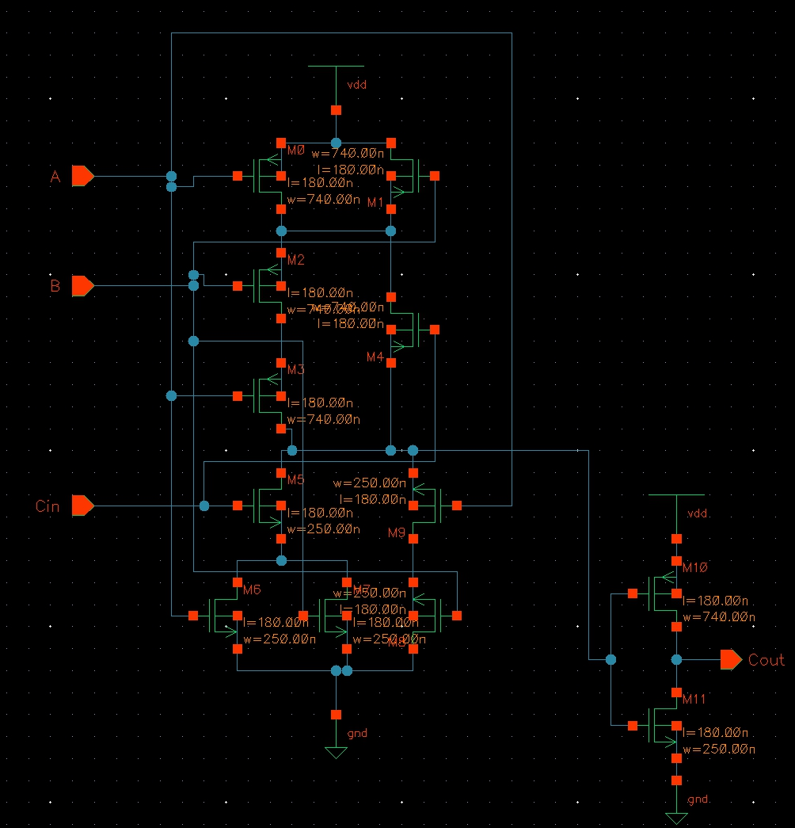

**CMOS_F2：**

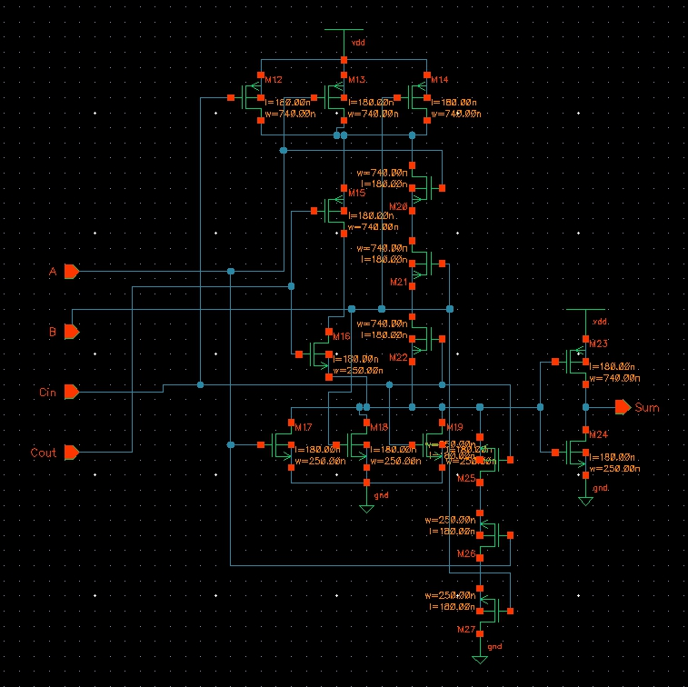

**FA：**

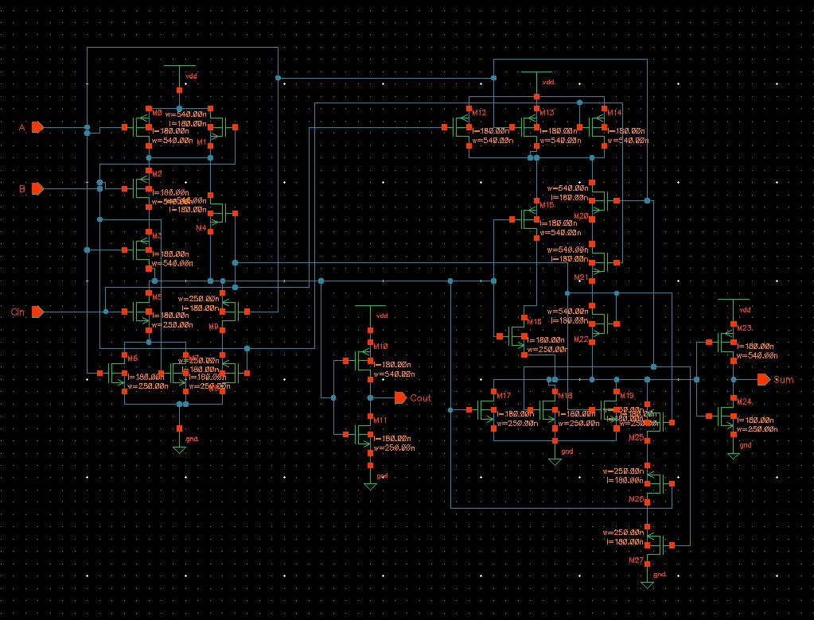

**C.【Layout view】**

**CMOS_F1：**

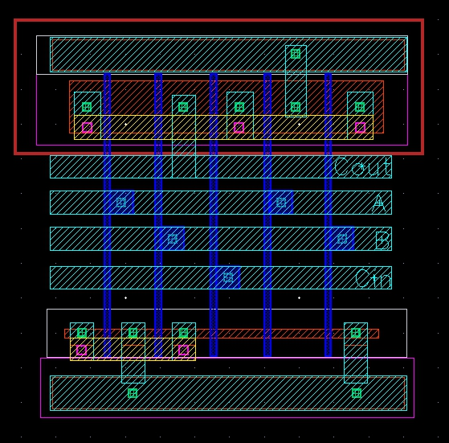

**CMOS_F2：**

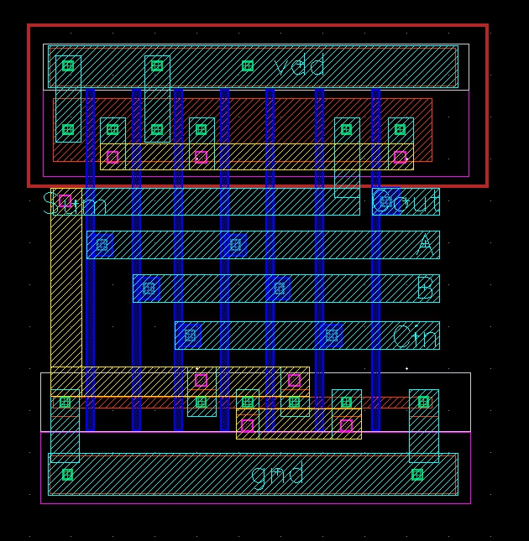

**FA：**

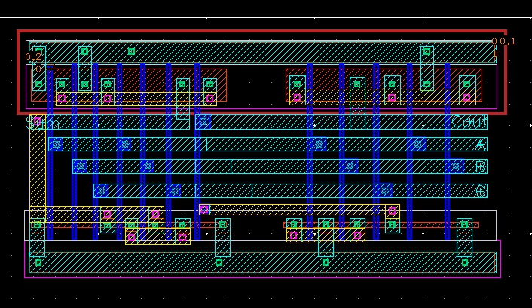

**D.【DRC successful view】*3**

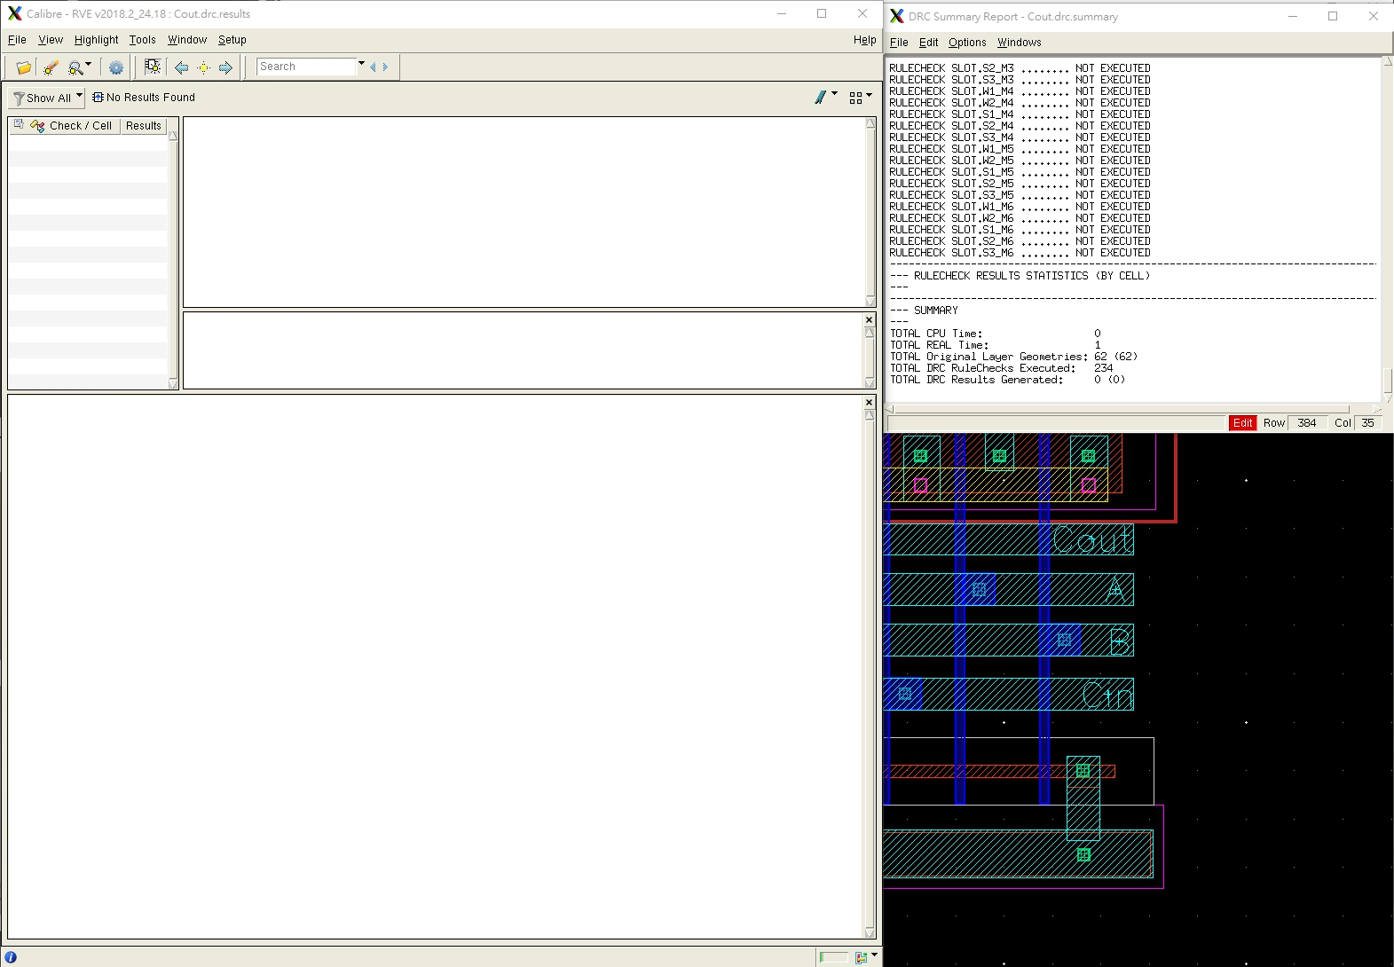

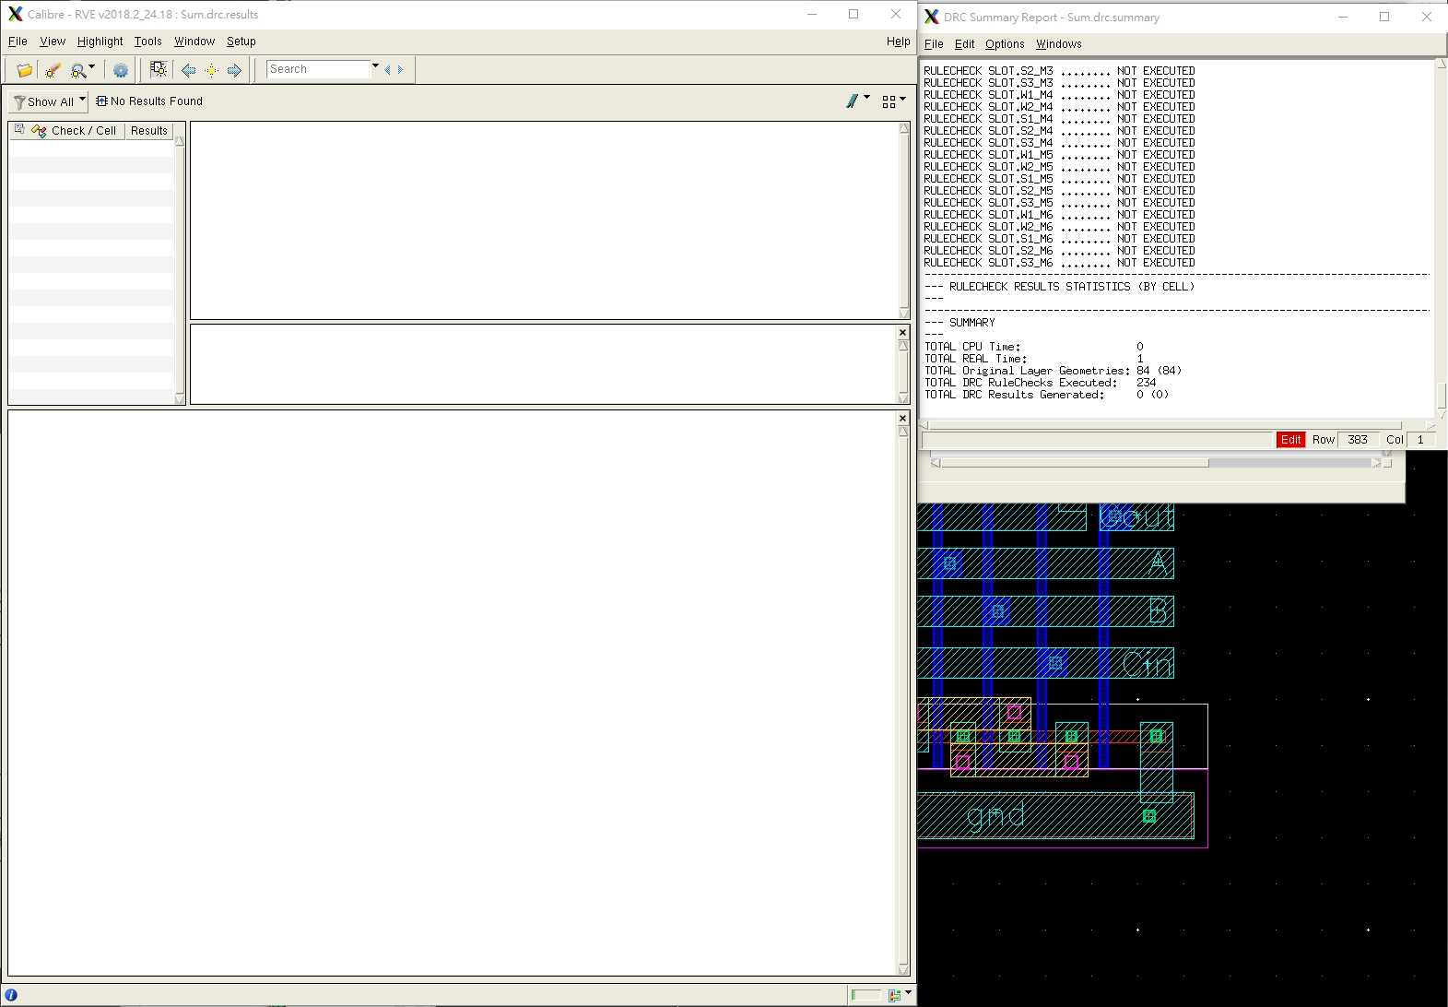

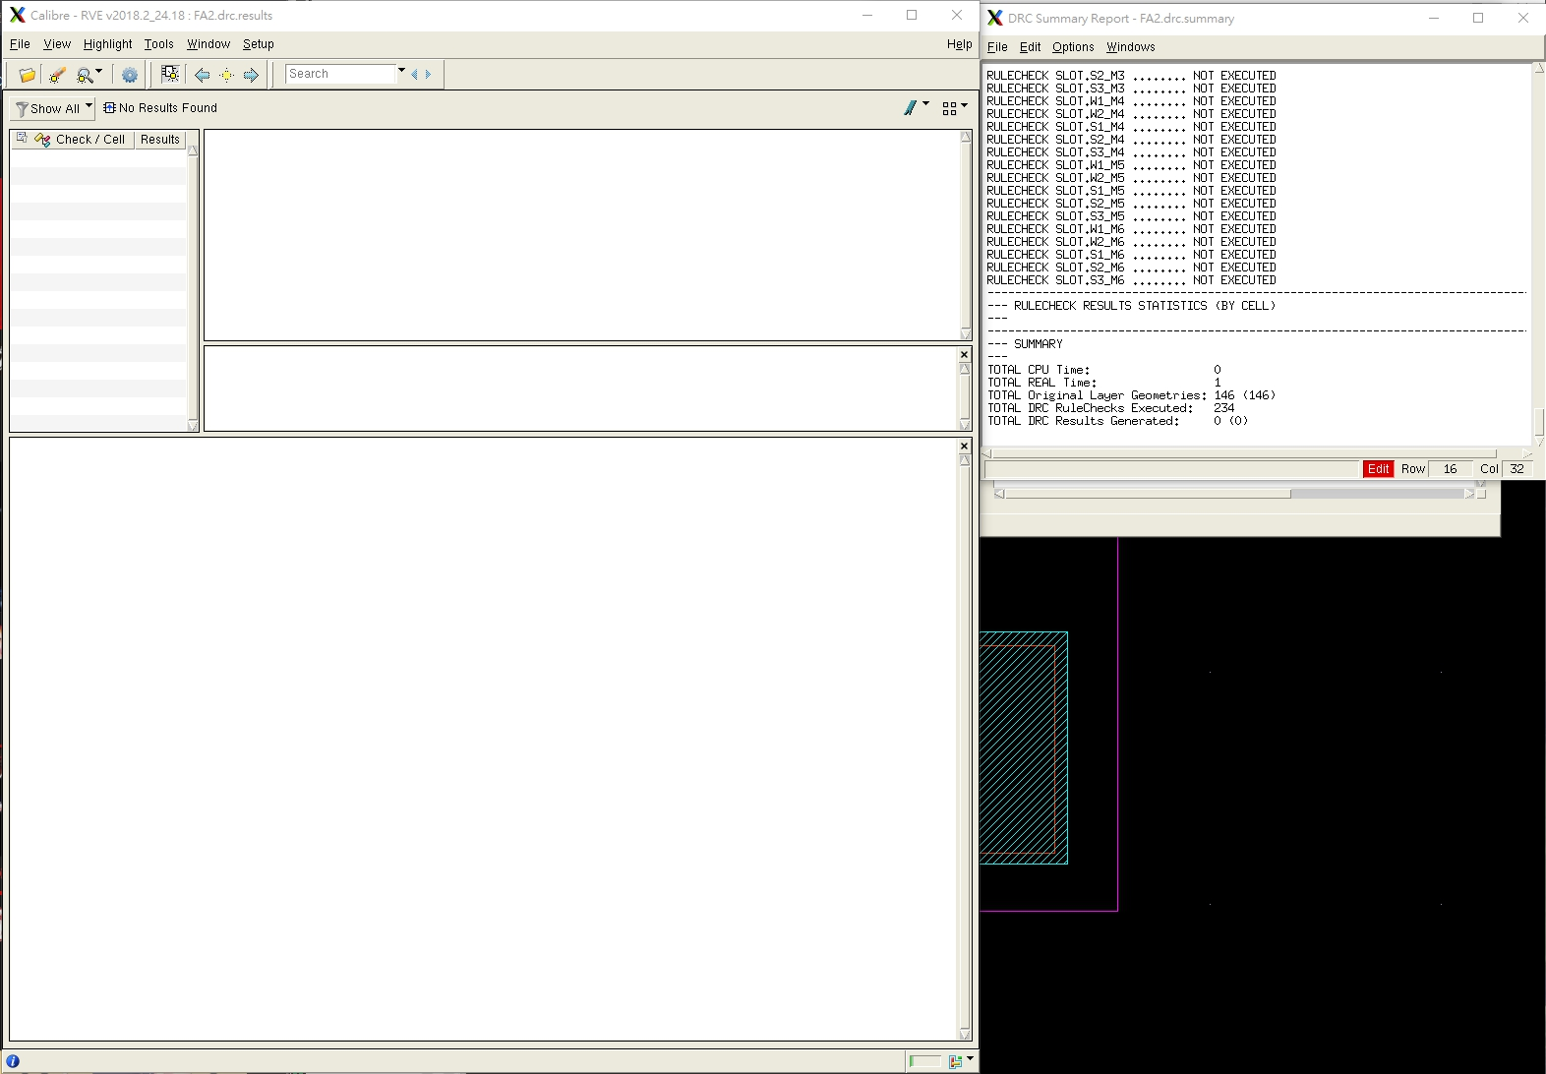

**E.【LVS successful view】*3**

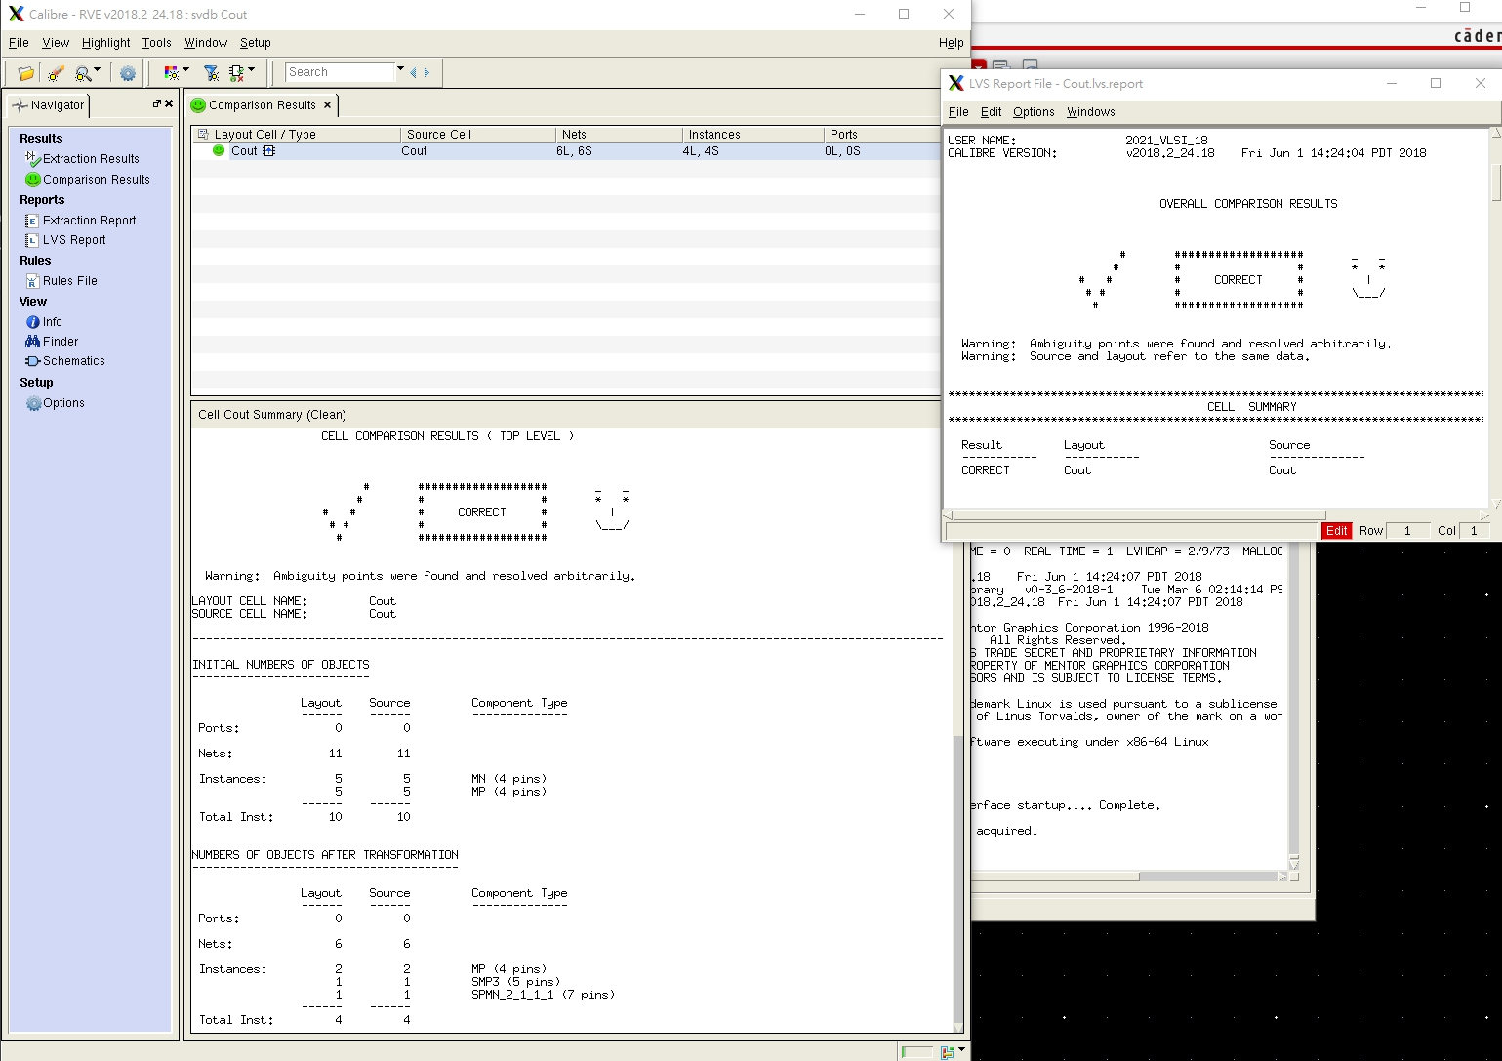

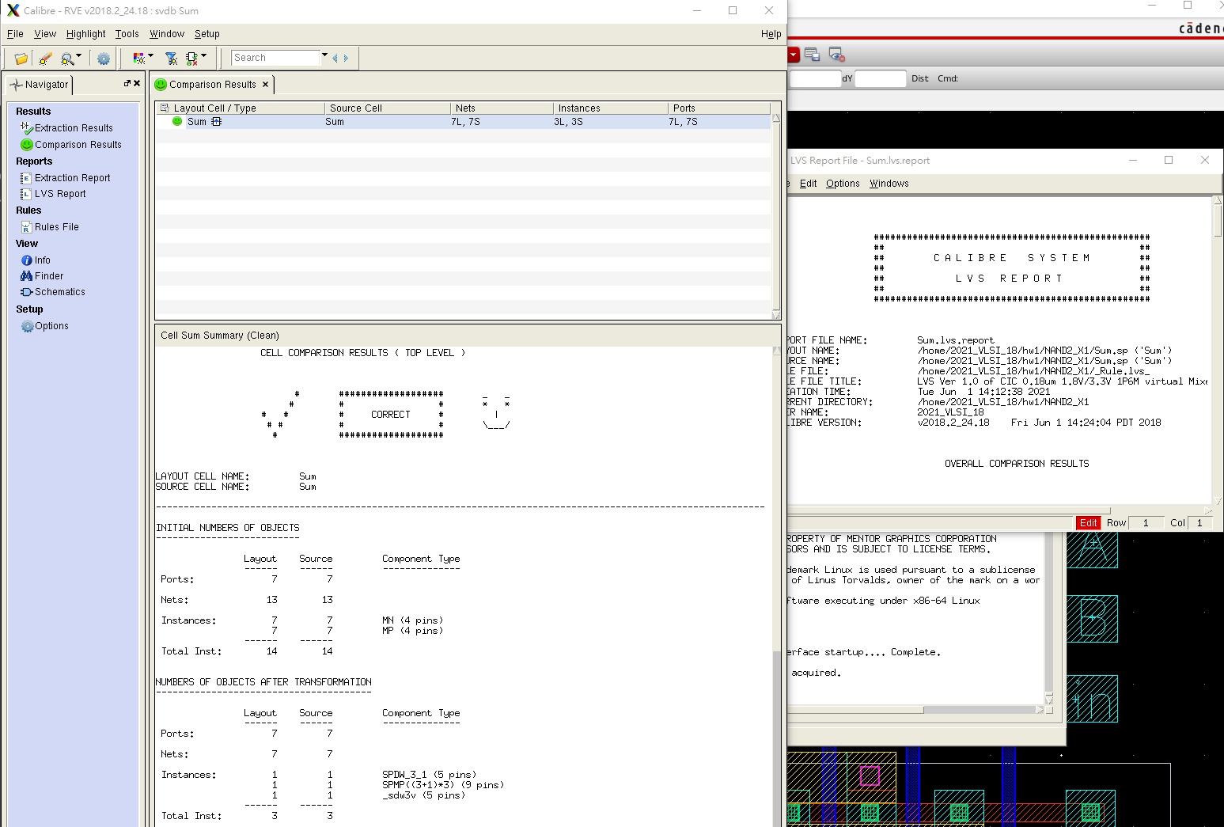

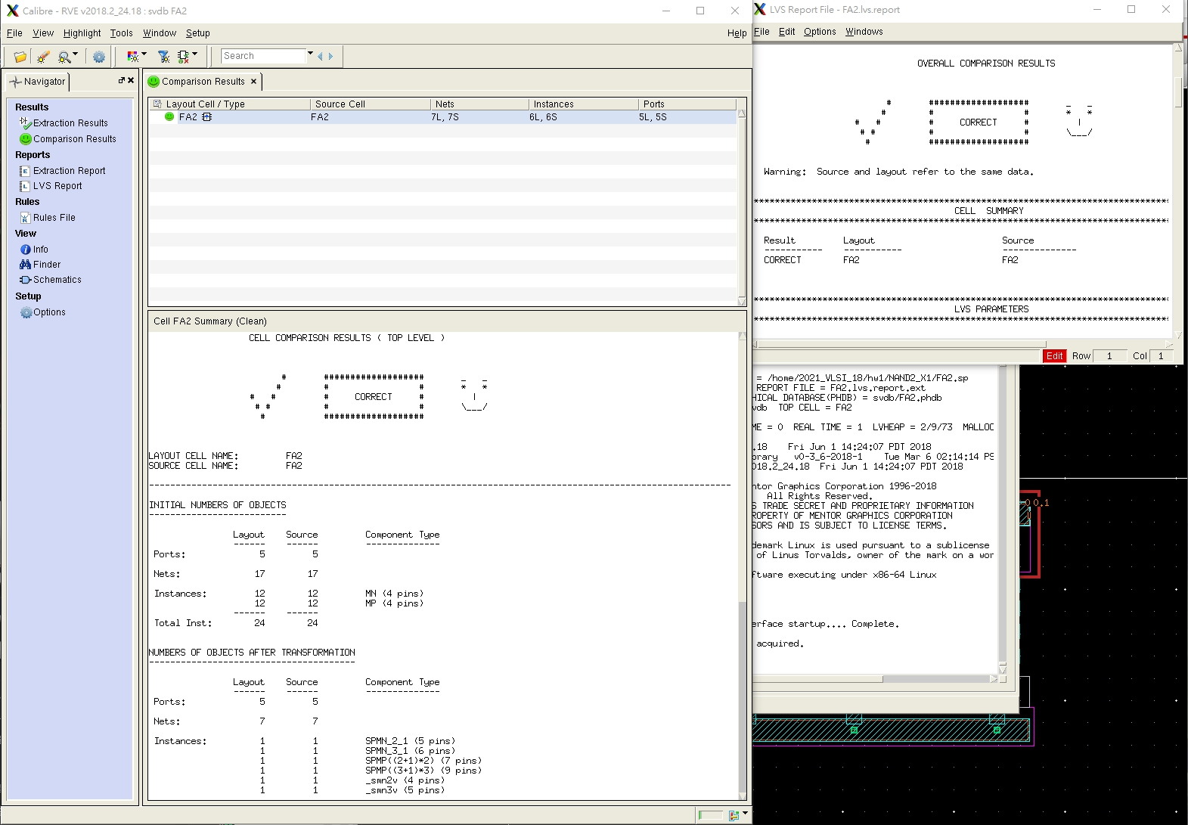

**F.【Pre-layout and Post-layout simulation waveforms】**

**(要包含所有真值表上的值)**

**F-1.(Pre-layout)*3**

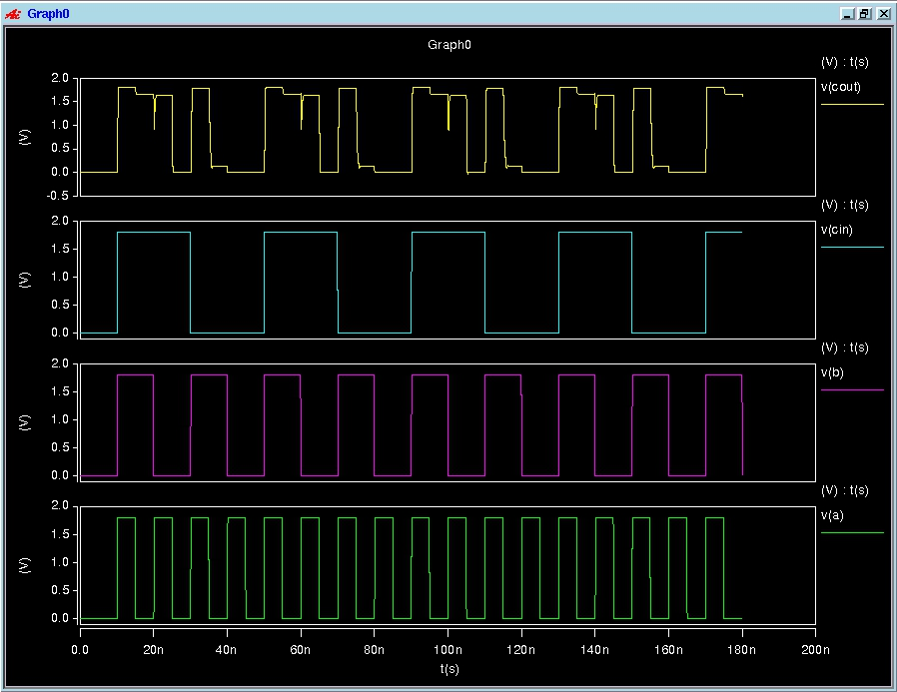

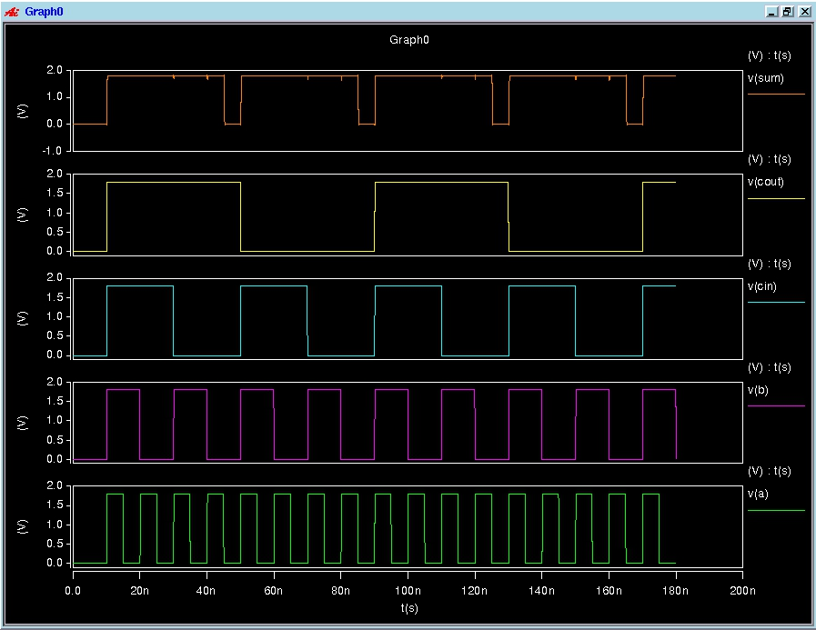

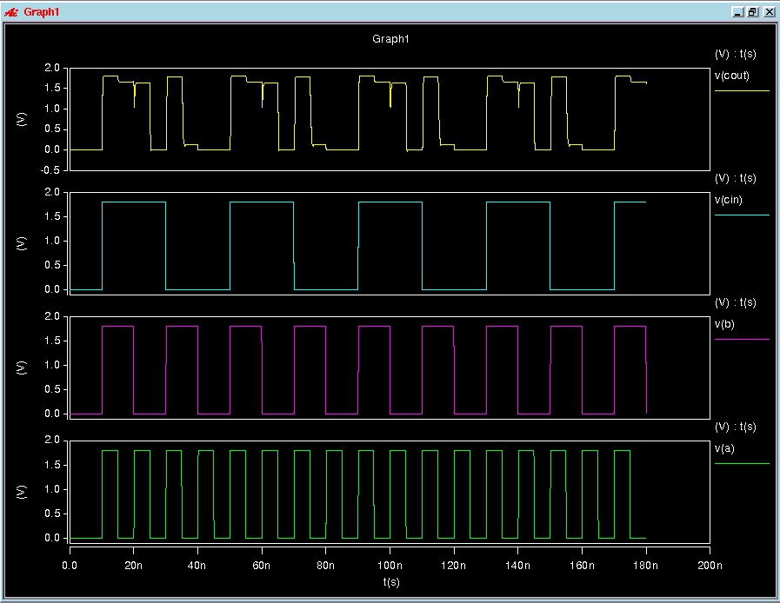

**F-2.(Post-layout)*3**

## 8bits-RCA(problem3)

**A.【list the results of propagation delay and compare the worse_case delay of Pre-simulstion and Post-simulation in Hspice simulation】**

**面積：??‬‬ um*um**

* **Hspice**

|  |  |  |  |  |  |  |  |  |  |  |  |
| --- | --- | --- | --- | --- | --- | --- | --- | --- | --- | --- | --- |
| Cload = 0.01 pF、Temp = 25°C、PC = TT | | | |  |  |  |  |  |  |  |  |
|  | | c[7] | | | sum[7] | | | SP(Watts) | DP(Watts) | | |
| TpHL | TpLH | Tpd | TpHL | TpLH | Tpd | max | min | avg |
| pre_sim | measure_a[0] |  |  |  |  |  |  |  |  |  |  |
| measure_b[0] |  |  |  |  |  |  |  |  |  |  |
| measure_c[0] |  |  |  |  |  |  |  |  |  |  |
| post_sim | measure_a[0] |  |  |  |  |  |  |  |  |  |  |
| measure_b[0] |  |  |  |  |  |  |  |  |  |  |
| measure_c[0] |  |  |  |  |  |  |  |  |  |  |

**B.【schematic view】**

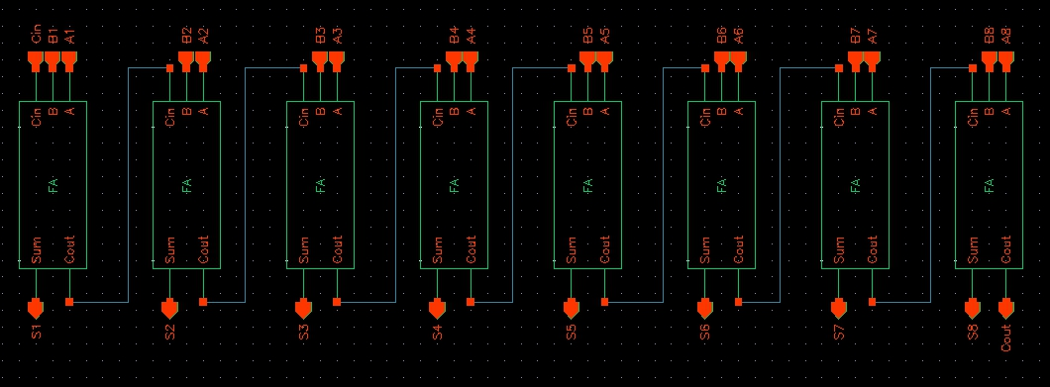

**C.【Layout view】Level 0**

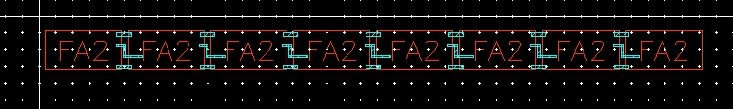

**D.【DRC successful view】**

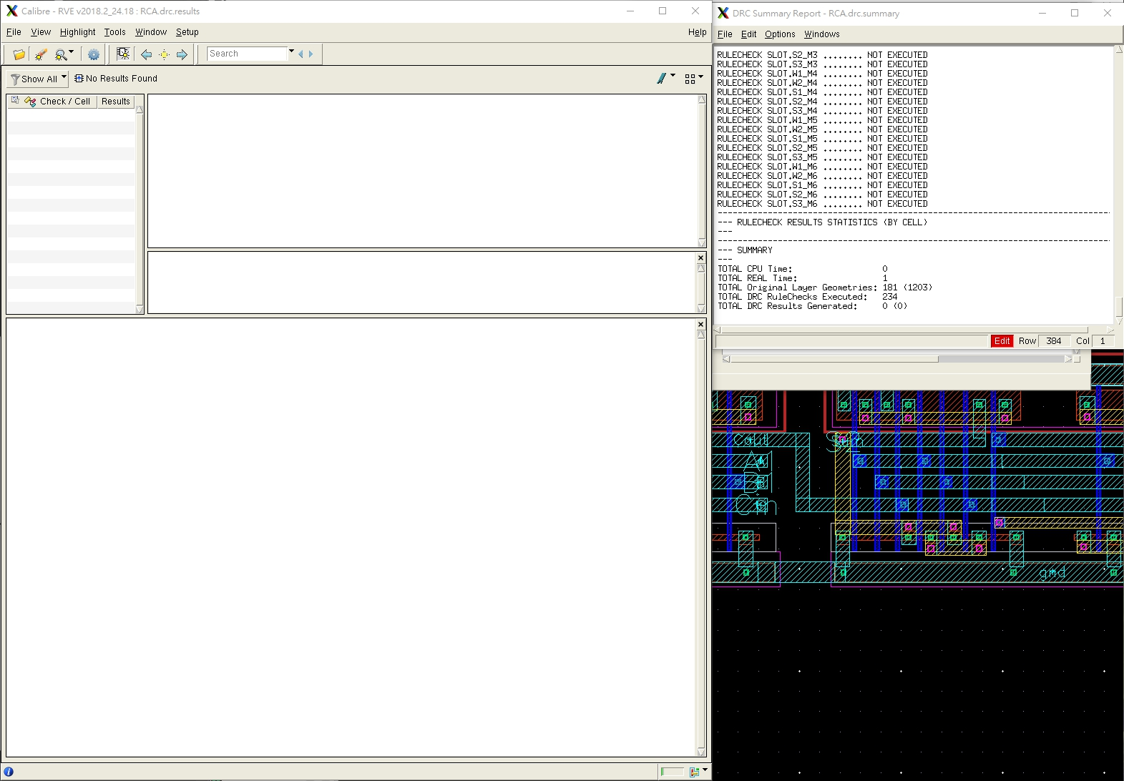

**E.【LVS successful view】**

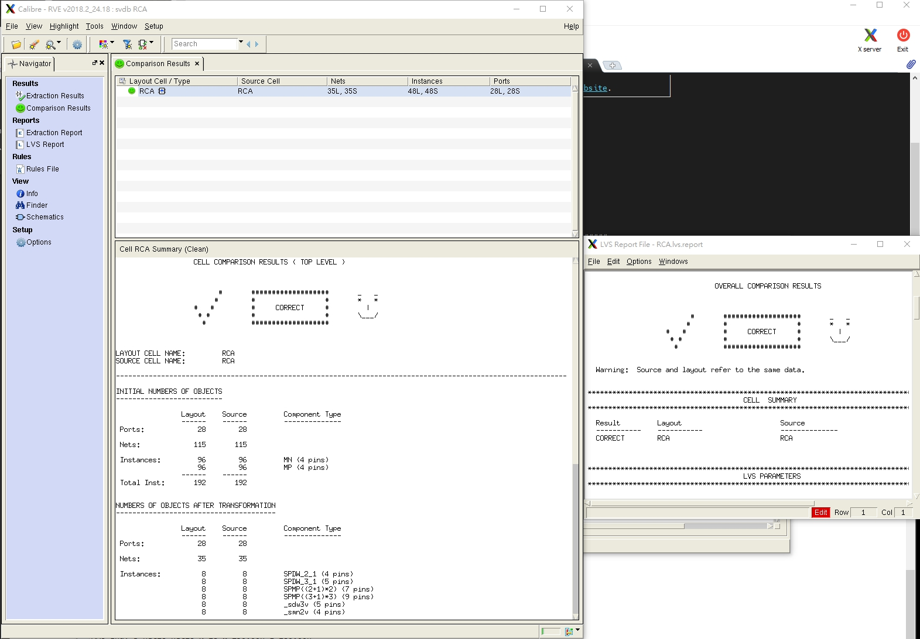

**F.【Pre-layout and Post-layout simulation waveforms】**

**(請測量最長路徑)**

**F-1.(Pre-layout)**

**F-2.(Post-layout)**